NLP Project details:
Core Novelty:
Gap you can position your project in: none of these papers actually combine rhetorical-role segmentation with a corrective/agentic RAG loop for legal text — segmentation work (rows 1–4) and CRAG (row 6) are separate literatures. That's your novelty claim.
The core novelty and unique aspect of your project lies in the architectural fusion of domain-specific semantic segmentation and an agentic self-correcting pipeline.
Typically, these two technologies are completely siloed:
- Standard Legal Segmentation: Researchers use models like InLegalBERT to classify Indian court judgments into structural roles (like "Facts" or "Issues"), but this usually stops at structural representation and positional context without addressing downstream retrieval or generation.
- Standard Agentic RAG: Developers build LangGraph-based Corrective RAG (CRAG) pipelines that grade documents and rewrite queries, but these systems still rely on naive text splitters that chunk documents by arbitrary character limits, blindly pulling in fragmented context before evaluating it.
Your Unique Differentiator: Your project connects these two paradigms by using semantic segmentation as the strict, non-negotiable filter for the CRAG state machine.
Instead of feeding the LangGraph agent arbitrary chunks of text, your system first isolates the exact rhetorical boundaries of the judgment. When a user asks a question, the retriever targets only the precisely identified legal roles—such as the "Arguments of Petitioner"—and feeds only those semantic blocks to the local grading model.
The grader then evaluates these highly specific legal arguments as "CORRECT," "AMBIGUOUS," or "INCORRECT," discarding irrelevant chunks and rewriting the query if the specific legal argument does not sufficiently answer the user's prompt. By replacing arbitrary text chunking with mathematical rhetorical role classification, your pipeline drastically reduces the search space and exponentially increases the accuracy and context precision of the final generated answer.

Pipeline:
Agentic Corrective RAG Pipeline Architecture
Stage 1: Ingestion and Semantic Segmentation The pipeline receives unstructured legal documents (PDFs/Text) and passes them through an InLegalBERT model fine-tuned on the ILDC dataset. Instead of using arbitrary text splitters, a Rhetorical Role Chunker categorizes sentences into specific legal functions (e.g., Facts, Issues, Arguments of Petitioner). These annotated chunks, along with their vector embeddings and role metadata, are stored in a ChromaDB Vector Database.
Stage 2: Precision Retrieval When a user submits a query (e.g., "What were the petitioner's main arguments?"), the system analyzes the query to determine the required rhetorical role. It then searches ChromaDB using a metadata filter (e.g., role = "Arguments of Petitioner") to retrieve strictly relevant chunks, systematically filtering out unrelated sections like the final ruling.
Stage 3: Corrective State Machine (LangGraph) The retrieved chunks enter a directed cyclic graph where a Relevance Grader Node evaluates their utility against the original query.
- Correct: The context directly answers the question and progresses as Verified Context.
- Ambiguous: The context is related but incomplete. It routes to a Fallback Node that queries web or legal databases to append missing information before becoming Verified Context.
- Incorrect: The context is irrelevant. The chunks are discarded, and the flow routes to a Query Rewriter Node that reformulates the user's prompt and loops back to Stage 2 for a fresh retrieval attempt.
Stage 4: Generation and Automated Evaluation The final Verified Context is sent to the Generation Node, where a primary LLM synthesizes a coherent legal response. This generated answer is immediately tested by the DeepEval framework for Faithfulness, Context Precision, and Context Recall. If it passes the unit tests, it is delivered as the Final Answer; if it fails (e.g., hallucinated a precedent), it flags an error to prevent the user from receiving inaccurate legal advice.

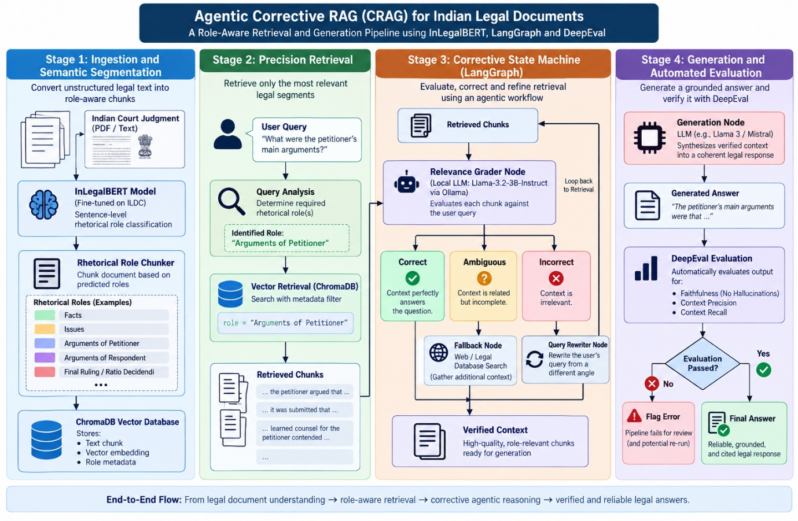
Architecture:


